Section 1: Case Summary

Scenario Title: | Armed Overdose
Keywords: | Safety, Opioids, Overdose, Police, Violence
Brief Description of Case: | In this case a 44 y/o M is brought in via EMS after receiving 0.4mg of naloxone for what is suspected to be an opioid overdose. He remains GCS 7 upon arrival in the resuscitation bay. The team will need to work through the differential for altered LoC and will find drug paraphernalia and a loaded weapon on the patient upon inspection. The case will end with successful treatment and consultation with local police with regard to weapon and contraband protocols.

Goals and Objectives
Educational Goal: | Safely manage a patient with a mixed overdose in the context of maintaining situation awareness and departmental guidelines around a patient found to be armed.
Objectives:  (Medical and CRM) | CRM  - Establish clear leadership  - Delegate roles in the resuscitation of an acutely unwell patient  - Communicate clearly amongst members of the team and employ closed loop communication  Medical  - Establish a differential diagnosis including sedative hypnotic and/or opioid toxidrome and trauma  - Treat a patient with a mixed overdose syndrome  - Effectively deal with a loaded weapon and drug paraphernalia using local protocols (e.g. RCMP or local police service)
EPAs Assessed: | N/A

Learners, Setting and Personnel
Target Learners: | ☐ Junior Learners |  | ☒ Senior Learners |  |  | ☒ Staff
 | ☒ Physicians | ☒ Nurses |  | ☒ RTs | ☒ Inter-professional
 | ☐ Other Learners:
Location: | ☐ Sim Lab |  | ☒ In Situ |  |  | ☐ Other:
Recommended Number of Facilitators: | Instructors: 1
 | Sim Actors: 0
 | Sim Techs: 1

Scenario Development
Date of Development: | April 7, 2021
Scenario Developer(s): | Drs. Brad Stebner and Jared Baylis
Affiliations/Institutions(s): | UBC
Contact E-mail:
Last Revision Date:
Revised By:
Version Number:

Section 2A: Initial Patient Information

- Patient Chart
Patient Name: Unknown Male |  |  |  | Age: 40 | Gender: M | Weight: 70kg
Presenting complaint: Altered LoC
Temp: 35 | HR: 80 | BP: 100/60 |  | RR: 12 | O₂Sat: 96% r/a | FiO₂: 100% NRB
Cap glucose: 5.2 mmol/L |  |  |  | GCS: 7 (E1 V2 M4 )
Triage note:
EMS notes state this patient was found downtown unresponsive. He was given one dose of 0.4mg IM naloxone and brought into the ED. Cap glucose 5.2 mmol/L. NRB at 15L/min applied. They also found a pool of blood around the patient and placed some gauze onto a bleeding scalp laceration.

Allergies: Unknown
Past Medical History: Unknown |  |  | Current Medications: Unknown

Section 2B: Extra Patient Information

A. Further History
No further patient history is known. There is no available information in the EMR.

B. Physical Exam
Cardio: Normal | Neuro: Low GCS, PERL 4mm
Resp: Normal | Head & Neck: Scalp laceration and small hematoma to left occiput
Abdo: Normal | MSK/skin: Track marks right ACF, has a loaded pistol and several baggies of “crystals” in pocket.
Other:

Section 3: Technical Requirements/Room Vision

A. Patient
☒ Mannequin (specify type and whether infant/child/adult)
☐ Standardized Patient
☐ Task Trainer
☐ Hybrid
B. Special Equipment Required
Monitors
IV access
Crash cart

C. Required Medications
Naloxone
Crystalloid

D. Moulage
Track marks right ACF
Street clothes with loaded toy pistol tucked into pants and two small baggies of “crystals” in pockets
Single 4x4 gauze soaked with ‘blood’

E. Monitors at Case Onset
☐ Patient on monitor with vitals displayed
☒ Patient not yet on monitor
F. Patient Reactions and Exam
Include any relevant physical exam findings that require mannequin programming or cues from patient
(e.g. – abnormal breath sounds, moaning when RUQ palpated, etc.) May be helpful to frame in ABCDE format.
None aside from GCS 7 (E1, V2, M4)

Section 4: Sim Actor and Standardized Patients

Sim Actor and Standardized Patient Roles and Scripts
Role | Description of role, expected behavior, and key moments to intervene/prompt learners. Include any script required (including conveying patient information if patient is unable)
RN | If patient not undressed for full exam within a few minutes, bedside nurse to prompt “we haven’t exposed the patient yet for examination”.

Section 5: Scenario Progression

Scenario States, Modifiers and Triggers
Patient State/Vitals | Patient Status | Learner Actions, Modifiers & Triggers to Move to Next State |  | Facilitator Notes
1. Baseline State  Rhythm: Sinus  HR: 80  BP: 100/60  RR: 12  O₂SAT: 96%  T: 35ºC  GCS: 7 |  | Expected Learner Actions  Apply monitors  Establish IV access  Apply defibrillator pads  Expose and examine patient  Order appropriate labs and ECG  Consider repeat naloxone dosing (although resp rate argues against this)  Consider IV fluids for hypotension and point of care ultrasound for differential diagnosis  Voice shared mental model with team including potential causes of altered level of consciousness  Involve RCMP (police) once weapon located | Modifiers  Changes to patient condition based on learner action  - naloxone-> minimal effect  Triggers  For progression to next state  - after action items complete or 5 minutes Phase 2
2. Persistent ALoC  HR: 85  BP: 105/70  RR: 12  O₂SAT: 89%  GCS: 5 (E1V1M4)  No longer moaning to pain |  | Expected Learner Actions  Consider CT head when not responding as expected  Perform secondary survey to assess for other etiologies  Consider pRBC transfusion when hypotension persists in context of scalp laceration  Consider discussion with poison control  Liaise with RCMP (police) and charge nurse with regard to ED safety protocols  Handle weapon +/- contraband according to local protocol | Modifiers  - Repeat dosing of naloxone -> Minimal effect  - Persistent bleeding from scalp laceration  - Head stapled or sutured -> Bleeding resolves  Triggers  - Completion of action items Phase 3
3.LIntubation  HR: 90  BP: 95/60  RR: 10  O₂SAT: 89% -> 99% with intubation  GCS: 3T |  | Expected Learner Actions  Perform endotracheal intubation with appropriate analgesia/sedation/paralytics and PPE  Consider peri-intubation IV crystalloid bolus + push dose pressor such as phenylephrine  Post intubation OG/NG tube  Post intubation CXR  Post intubation sedation + analgesia  Consult ICU and order CT head if not already done | Modifiers  - Intubation ΔO₂SAT to 99%  Triggers  - Completion of action items -> Phase 4
4. Admission |  | Expected Learner Actions  Admit to ICU for mixed opioid / sedative hypnotic overdose | END Scenario

Appendix A: Laboratory Results

CBC  WBC 10.2  Hgb 145  Plt 376  Lytes  Na 137  K 3.6  Cl 106  HCO₃ 21  AG 10  Urea 5.7  Cr 75  Glucose 6.1  Extended Lytes  Ca 2.12  Mg 0.73  PO₄ 1.18  Albumin 42  TSH 2.37  VBG  pH 7.29  pCO₂ 38  pO₂ 97  HCO₃ 21  Lactate 3.3 | Cardiac/Coags  INR 1.0  aPTT 24  Biliary  AST 29  ALT 22  GGT 12  ALP 70  Bili 12  Lipase 27  Tox  EtOH <2  ASA <0.3  Tylenol <66

Appendix B: ECGs, X-rays, Ultrasounds and Pictures

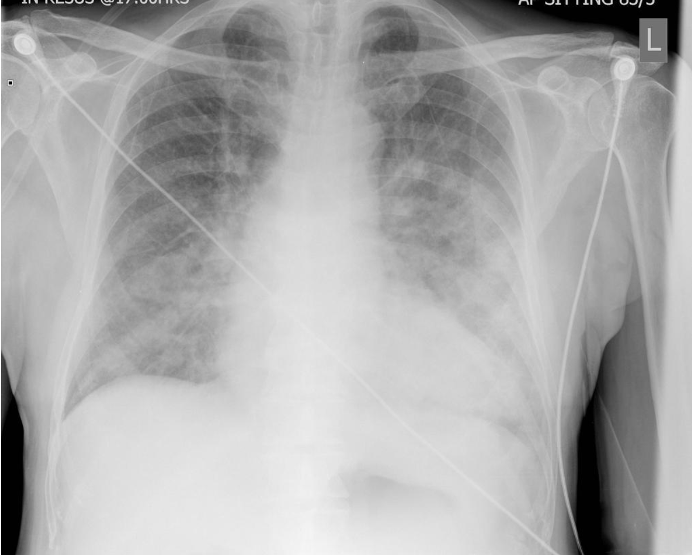  Case courtesy of Dr Jeremy Jones, Radiopaedia.org, rID: 6463  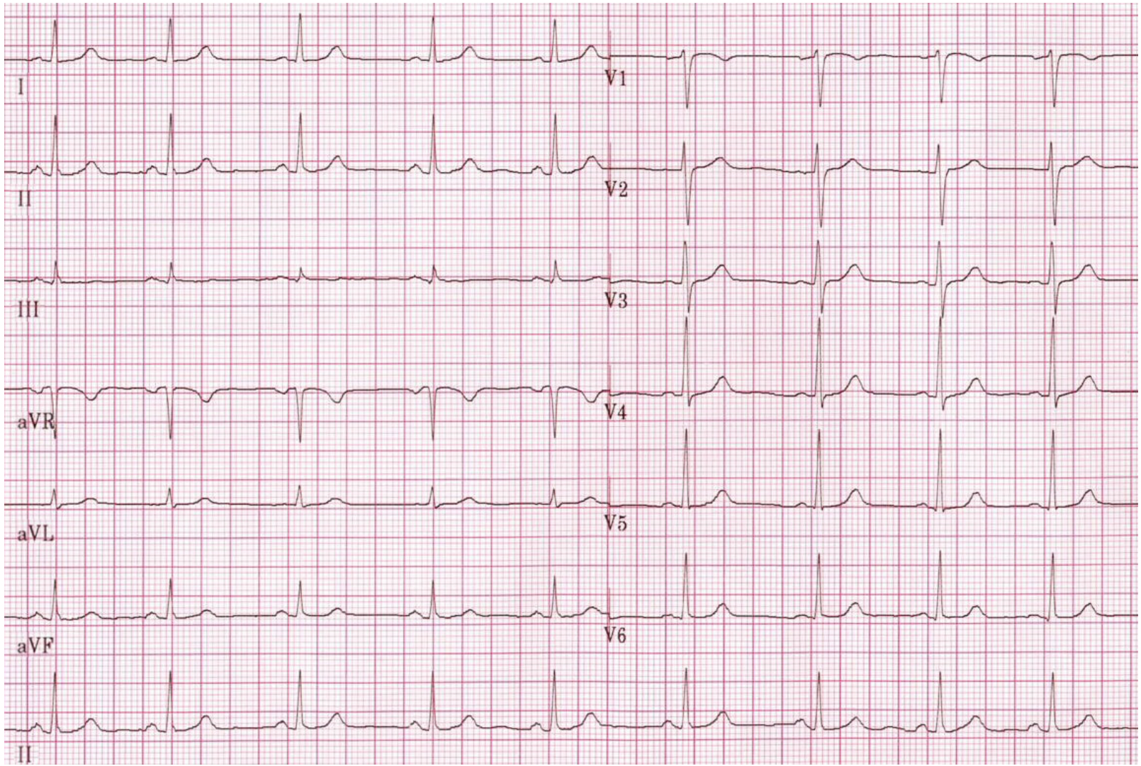  https://en.ecgpedia.org/index.php?title=Normal_Tracing | 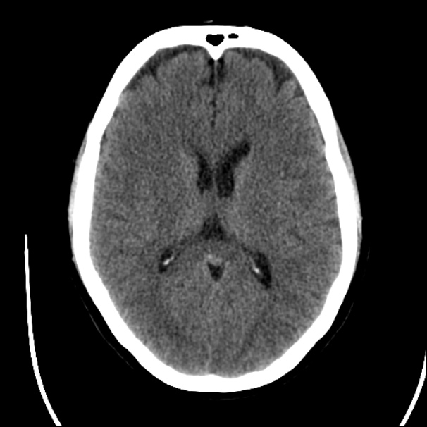  Case courtesy of Dr David Cuete, Radiopaedia.org, rID: 23768
Appendix C: Facilitator Cheat Sheet & Debriefing Tips

Include key errors to watch for and common challenges with the case. List issues expected to be part of the debriefing discussion. Supplemental information regarding any relevant pathophysiology, guidelines, or management information that may be reviewed during debriefing should be provided for facilitators to have as a reference.

- What is the differential diagnosis for a patient with altered mental status?
- What are your major safety concerns with a patient presenting with loaded weapons and drug paraphernalia?
- What are your local protocols with regards to handling unknown illicit substances?
- What is your local protocol for dealing with weapons found on patients?
- What are your obligations as a medical professional in reporting incidents that involve weapons?

References

- https://emergencymedicinecases.com/opioid-misuse-overdose-withdrawal/
- https://www.royalcollege.ca/rcsite/bioethics/cases/section-3/reporting-patients-harm-others-public-safety-e
- https://pubmed.ncbi.nlm.nih.gov/16552279/

